**DELAWARE COUNTY DISTRICT LIBRARY BOARD OF TRUSTEES**

**Agenda • Regular meeting • March 19, 2024**

**5:00 pm • Liberty Branch • 7468 Steitz Rd, Powell, OH 43065**

1. Call to order (Mr. Tiede)
2. Pledge of Allegiance (Mr. Tiede)
3. Roll call (Ms. Grossenbacher)
4. Public participation
5. Review, approve minutes (Mr. Tiede)  
   *Anticipated motion:*

* To approve the minutes of the records commission meeting of February 20, 2024. (attachment #02a)
* To approve the minutes of the regular meeting of February 20, 2024. (attachment #02b)

1. President’s report (Mr. Tiede) (attachment #03)
2. Fiscal Officer’s report and financial business (Ms. Grossenbacher) (attachment #05)

*Anticipated motions:*

* To approve the February financial reports, payment transaction listing, and investments. (attachment #05)
* To allow the Fiscal Officer to update the line of credit with First Commonwealth Bank for credit/purchasing cards to $40,000 for purchasing needs related to DCDL.
* To approve the following DCDL employees to be Authorized Users of Credit Cards from First Commonwealth for DCDL:

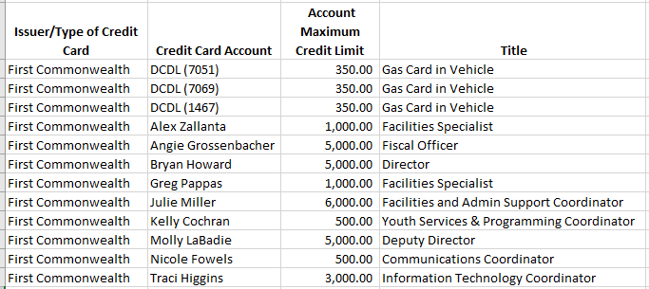

1. Director’s Report (Mr. Howard) (attachment #04)
2. Friends of the Library Report (Ms. Klatte) (attachment #06)
3. Committee reports

* Finance/Budget (Mr. Allen, Mr. Ike)
* Liberty (Mr. Tiede, Ms. Quaine)
* HR (Ms. Skinner, Ms. Kipfer)
* Policy (Mr. Tiede, Mr. McCoy)

1. Unfinished business (Mr. Tiede)
2. New business (Mr. Tiede)
3. Adjourn (Mr. Tiede)